Cloud Computing

**Name:** Jerusha Angel K

**Register No**: 727721EUCS049

Day-7

**Day 7_ELB_CE1**

**Content Description:**

Host a static website using classic LoadBalancer

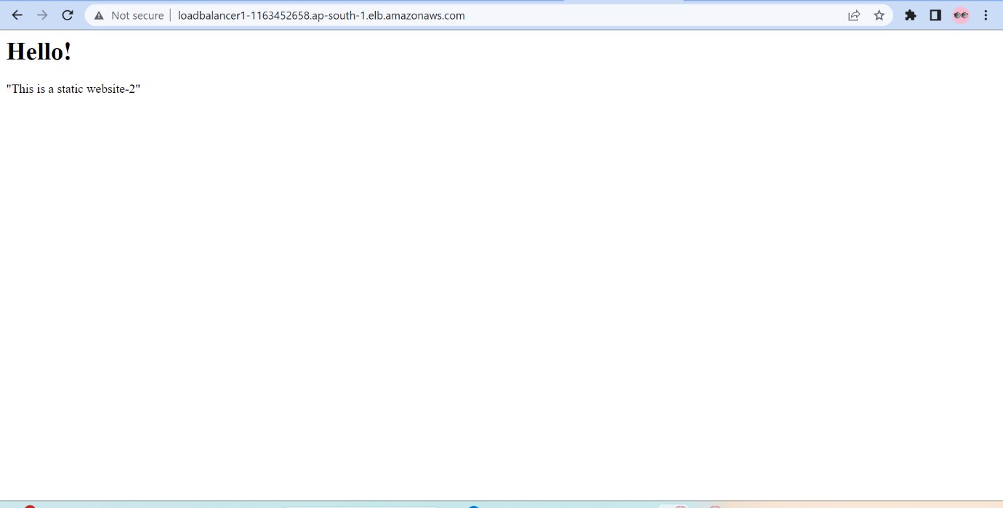

**Day 7_ELB_CE2**

**Content Description:**

Host multiple pages website using Application Load Balancer

